HF Project Briefing Document

This document contains three options for you to consider for your HF projects. Please select one.

- Designing an ergonomic workstation
A web developer is at risk of developing musculoskeletal disorders due to prolonged sitting and repetitive motions. This is their current workstation set-up:
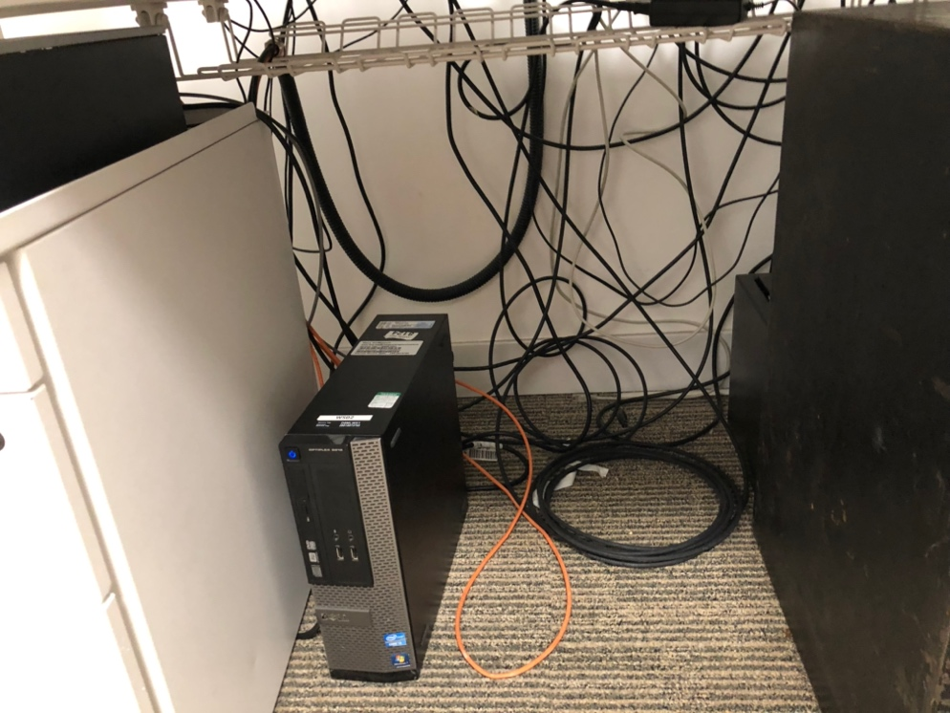
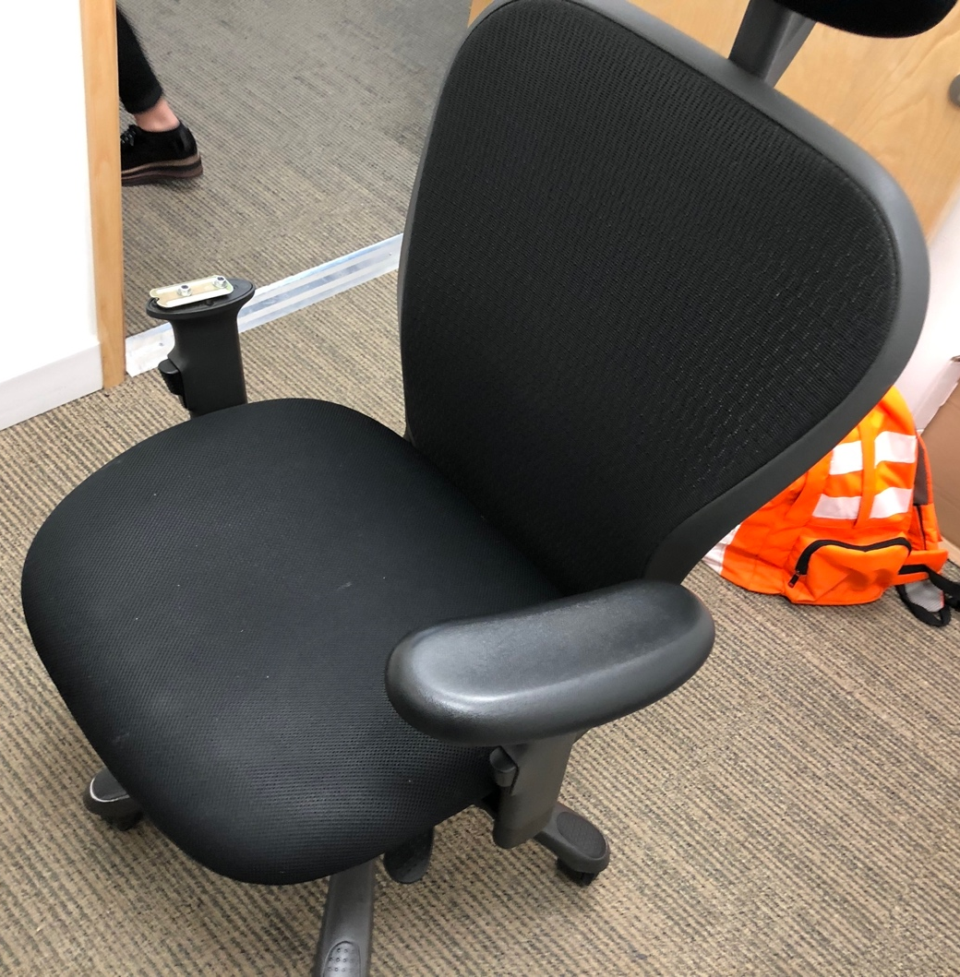
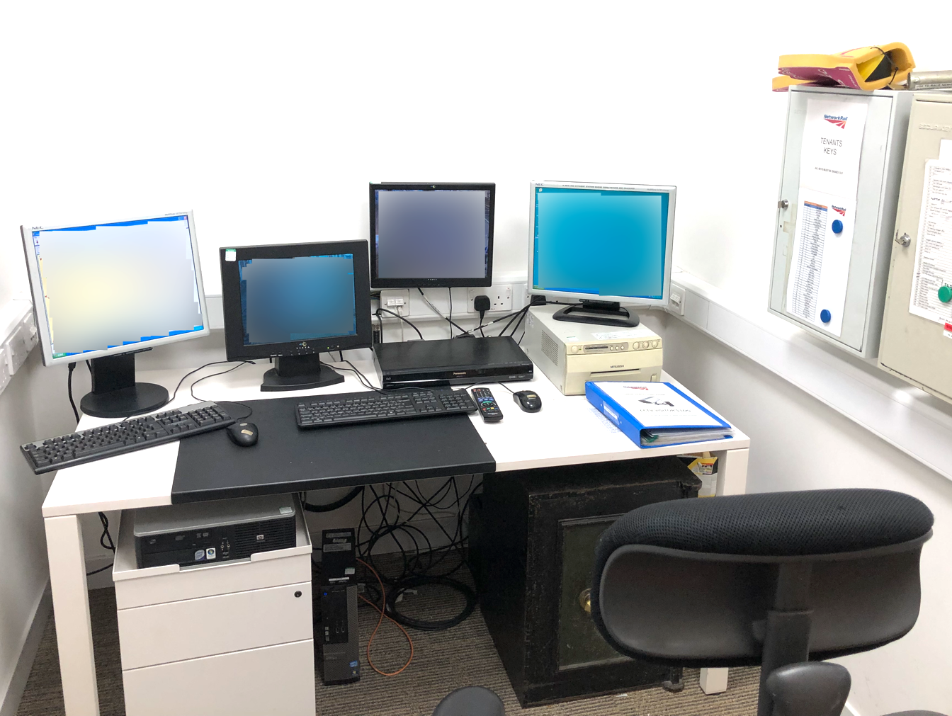
The HFE issue to be solved is to design a workstation that minimises the risk of injury and discomfort by accommodating the web developer's physical and cognitive needs.

To start, let’s consider the potential user needs:
- There are currently multiple monitors on the desk. Considering their job role (web developer), they are likely going to need multiple desktop views to support their job role.
- Would they likely need as much physical storage located close to their workstation as they currently have?
- Multiple PC’s running could potentially make the room quite warm? Would this need to be considered/managed?
- If the user works all day at their desk, ways to introduce some flexibility in the workstation set-up may be beneficial.

What kind of HF assessment would help uncover the potential HF issues associated with working on this workstation, and could inform a change that would better accommodate the web developer's physical and cognitive needs?

- Evaluating a consumer product
A small café on a university campus is a regular for many university students to work from. The café offers a variety of drinks, and some of the most popular ones with the university students are the café’s smoothies and iced frappés, both of which utilise a blender. There is only one blender in the café and staff have made several complaints about it, including:
- The lid keeps coming off when the smoothie maker is turned on. This means the staff must hold it on the whole time and wait for the drink to be blended.
- The drinks keep coming out too lumpy, which has led to several complaints from the customers.
- Once blended, it is hard to get the full cup of smoothie or frappé out the blender, which results in bits getting stuck under the blade.
This is the current blender design:
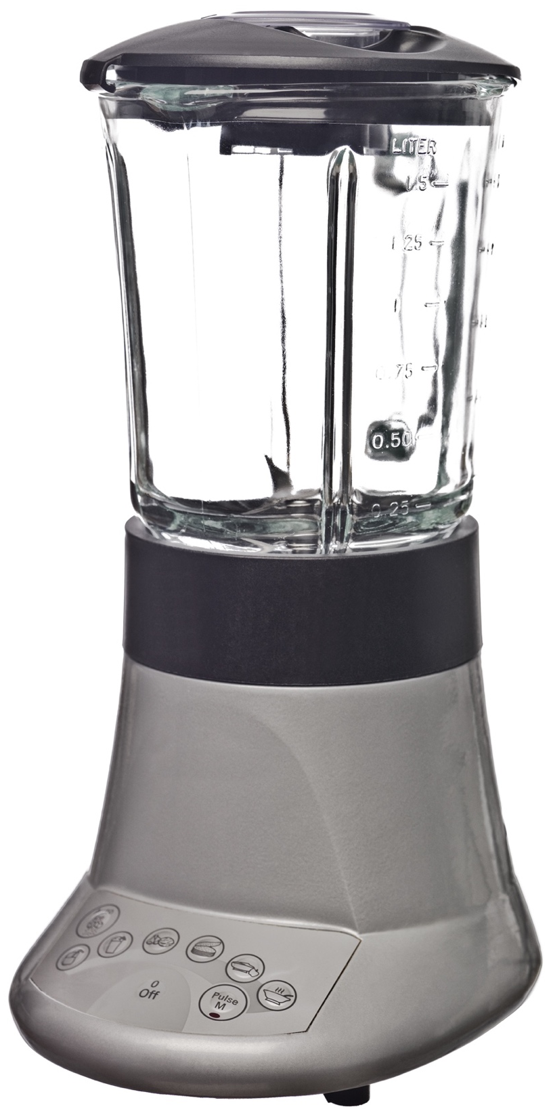
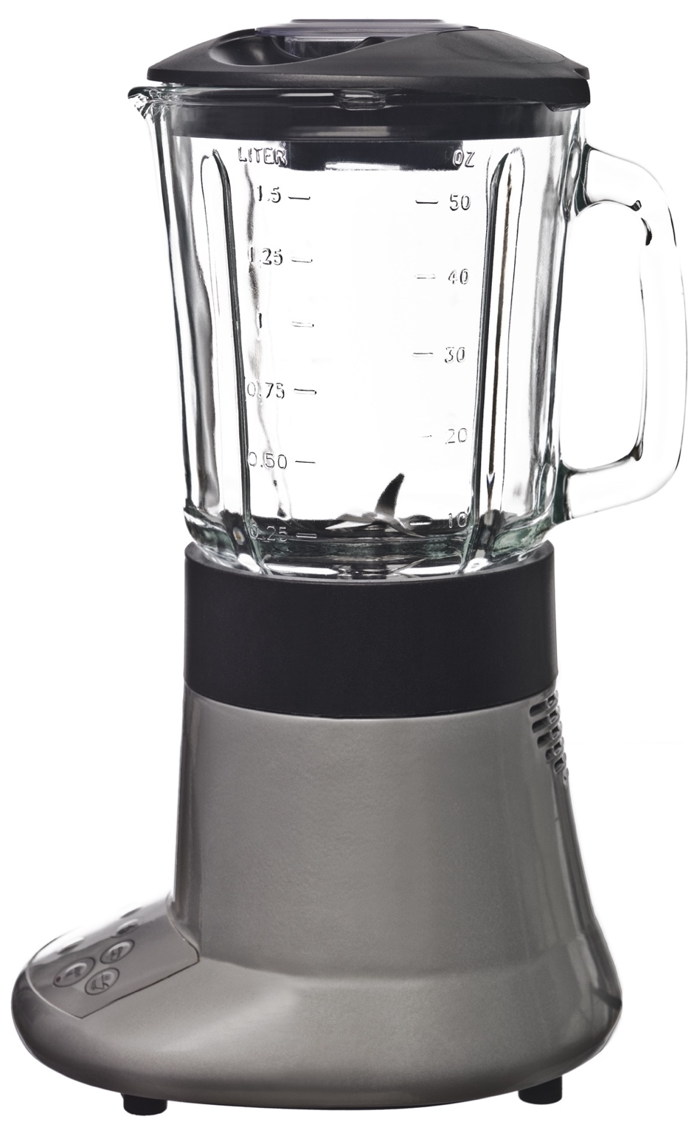

The HFE issue to be solved is to identify the design flaws that contribute to the difficulty of using the blender and propose changes to improve its usability and safety for the café staff.

To start, let’s have a look at the blender, consider what aspects could be causing the issues? Think about all the areas of the blender the user interacts with, e.g., the buttons, the handle, the base (to position it), the lid, the side of the container (e.g., to look for measurements). Then think about the context the blender is used in (e.g., a busy café with many students working in it).

What kind of HF assessment could help uncover the specific use issues, and could inform what HF recommendations would be appropriate to potentially solve these? Also, consider how the design of the blender could best support this specific use case?

- Conducting a workplace safety analysis:
Conduct a workplace safety analysis for a warehouse that handles heavy machinery and equipment. The problem is that the warehouse is at risk of workplace accidents or injuries due to poor workplace design or inadequate worker training.
Here are some images taken in and around our warehouse of interest:
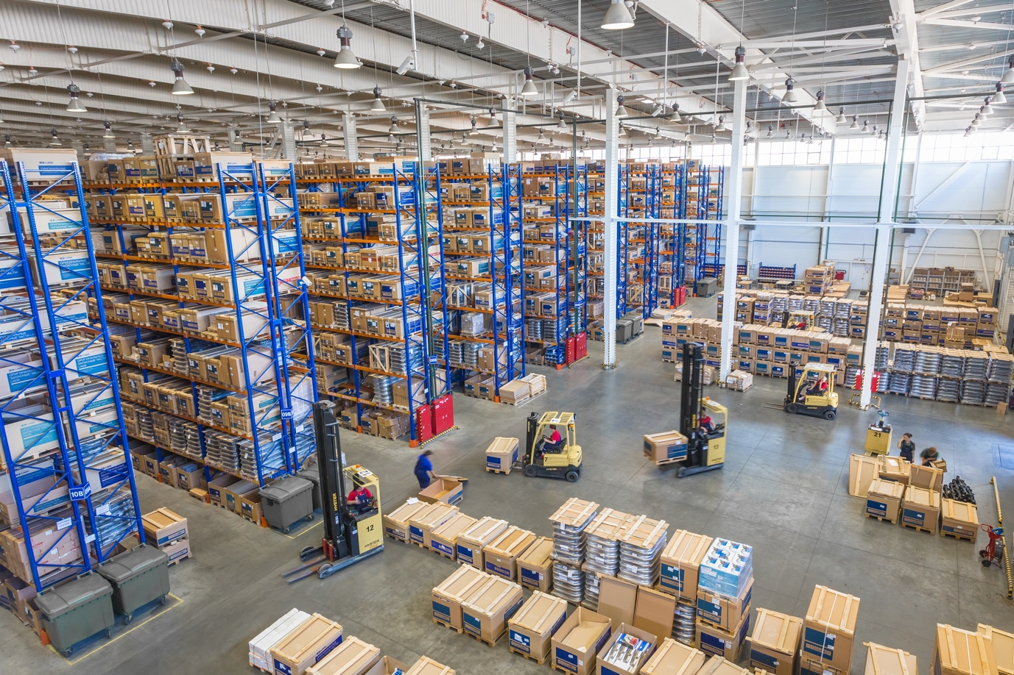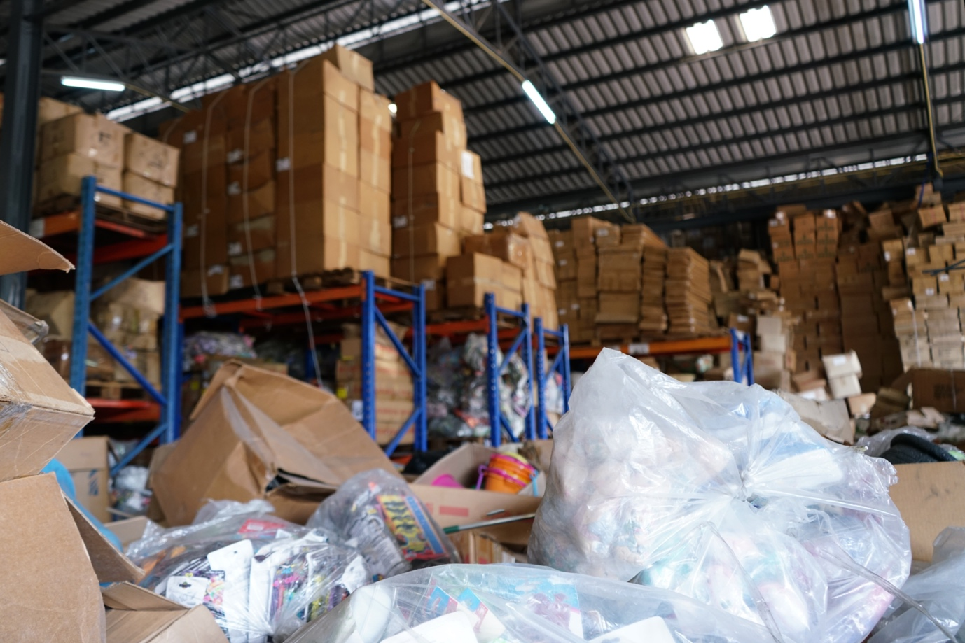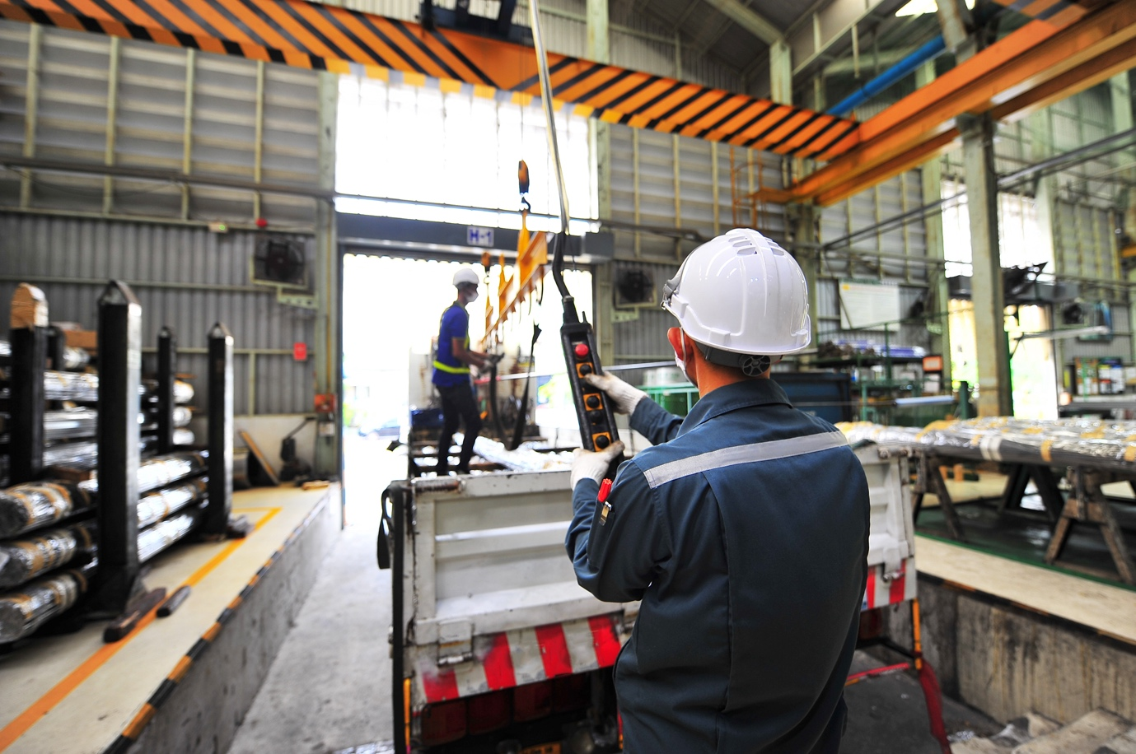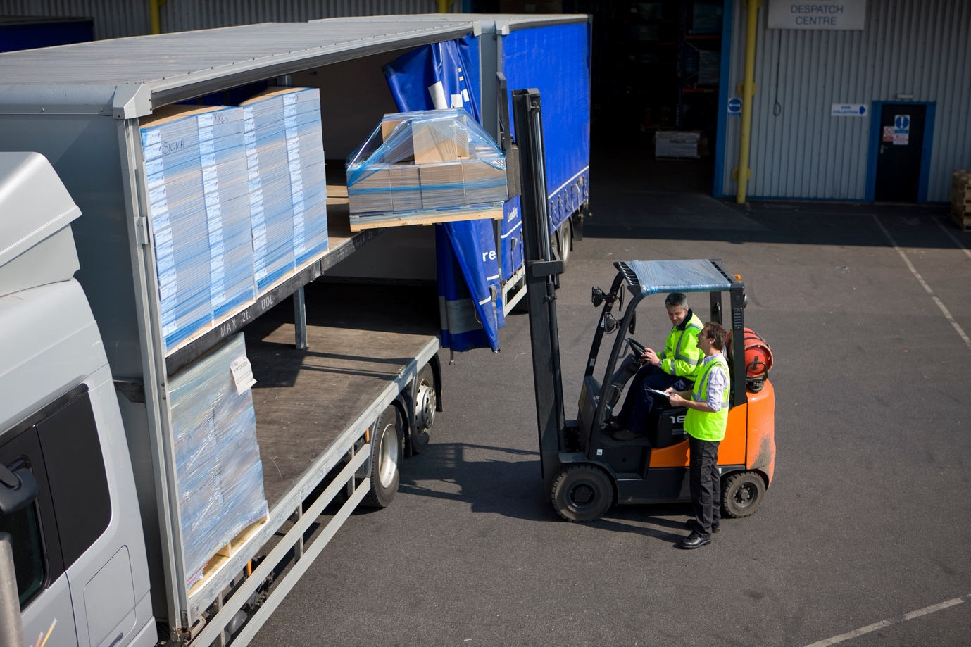

The HFE issue to be solved is to identify the safety hazards and risks, and propose changes that improve the workplace design, equipment layout, or worker training programs to reduce the risk of accidents or injuries.

Let’s consider what the likely key tasks to be carried out in the warehouse are:
- Accept delivery of heavy machinery/equipment (forklift may be required)
- Logging of delivered inventory (models, quantity etc.)
- Movement of delivered inventory to appropriate storage place within warehouse (forklift or pallet truck may be required)
- Retrieval and re-distribution of machinery out of warehouse to its final destination

What kind of HF assessment would help identify the safety hazards and risks associated with the different tasks the warehouse workers need to carry out, and thus help you make appropriate proposals to help reduce / eliminate these?

